1. There are various elements in the excel interface and are explained below:

Ribbon: The Ribbon is the horizontal toolbar at the top of the Excel window. It's divided into tabs, each containing groups of related commands. You can access various functions, such as formatting, formulas, data, and more, by clicking on the appropriate tab.

Tabs: Tabs are located on the Ribbon and represent different categories of functions. Common tabs include Home, Insert, Page Layout, Formulas, Data, Review, and View. Clicking on a tab reveals groups of related commands within that category.

Groups: Within each tab, you'll find groups of commands related to specific tasks. For example, the Home tab includes groups like Clipboard, Font, Alignment, Number, and more. These groups organize commands for easy access.

Quick Access Toolbar: This customizable toolbar is located above or below the Ribbon and provides quick access to frequently used commands. You can add or remove commands to tailor it to your needs.

Formula Bar: The Formula Bar, located above the worksheet, displays the content of the selected cell, including text, numbers, and formulas. You can edit cell content directly in the Formula Bar.

Workbook: A workbook is a collection of one or more worksheets. Each workbook is opened in a separate window and can contain different types of data or analyses.

Worksheet: A worksheet is a grid of cells organized into rows and columns. It's where you input, manipulate, and analyze data. Each worksheet has a name and can be added, deleted, or renamed.

Columns and Rows: Columns run vertically, and rows run horizontally on the worksheet. Columns are labeled with letters (A, B, C, etc.), and rows are labeled with numbers (1, 2, 3, etc.). Cells are the intersections of rows and columns where you input data.

Cell: A cell is a single rectangular box in a worksheet where you can input text, numbers, formulas, or functions.

1. Some of the applications of excel can be explained below:

Finance and Accounting

Business and Management

Marketing and Sales

Human Resources

Employee data management

Research and Analytics

Healthcare and Science

1. 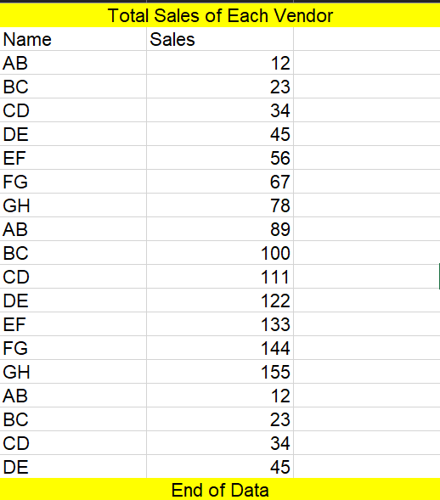
2. Some of the shortcut keys in excel are as follows:

Ctrl + 1: Opens the "Format Cells" dialog box, allowing you to format the selected cells with various options such as font, number format, alignment, border, and fill.

Ctrl + B: Applies or removes bold formatting to the selected text.

Ctrl + I: Applies or removes italic formatting to the selected text.

Ctrl + U: Applies or removes underline formatting to the selected text.

Ctrl + 5: Applies or removes strikethrough formatting to the selected text.

Ctrl + Shift + F: Opens the "Font" dialog box to modify font settings.

Ctrl + Shift + P: Applies or removes point mode in the "Format Cells" dialog box.

Ctrl + Shift + F3: Creates a name using the text in adjacent cells as a label for the selected cells. Useful for creating named ranges.

Ctrl + Shift + ~: Applies the "General" number format to the selected cells, displaying numbers without any specific formatting.

Ctrl + Shift + $: Applies the "Currency" number format with two decimal places to the selected cells.

1. Microsoft Excel is a widely used spreadsheet software that offers a range of analytical and data management capabilities.

Ubiquity and Familiarity

User-Friendly Interface

Versatility

Ease of Data Entry

Interactive Formulas and Functions

1. 